algoritma dan pemrograman pertemuan 14

01tple029 r v.629

Thoty Ariesandes 221011403066

Tugas Praktikum

Lat 4_1

#include <iostream>

using namespace std;

main()

{

int h;

cout<<"Masukkan Kode Hari [1-7] : ";

cin>>h;

cout<<"*====================*\n\n"<<endl;

switch (h)

{

case 1 :

cout<<"Senin";break;

case 2 :

cout<<"Selasa";break;

case 3 :

cout<<"Rabu";break;

case 4 :

cout<<"Kamis";break;

case 5 :

cout<<"Jum'at";break;

case 6 :

cout<<"Sabtu";break;

case 7 :

cout<<"Minggu";break;

default:

cout<<"Code not found!";

}

cout<<"\n\n\n*====================*";

}

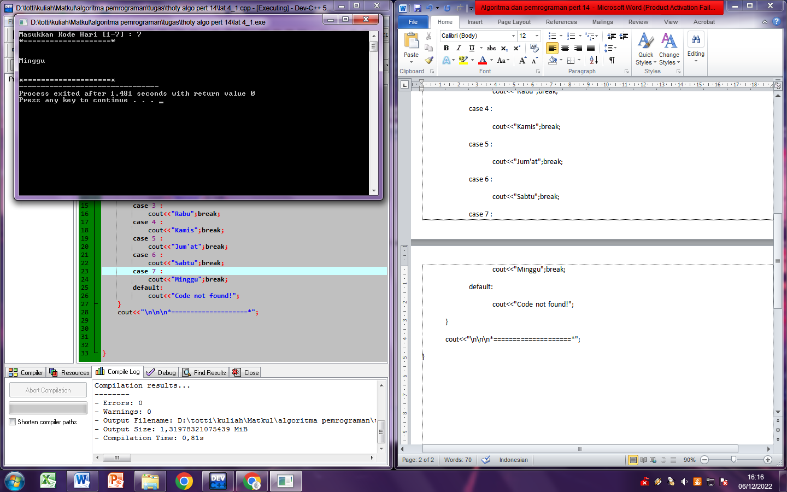

Lat 4_2

#include <iostream>

using namespace std;

main()

{

char h;

cout<<"*Program menentukan Luas dan keliling Bangun Datar*\n";

cout<<"*====================*\n"<<endl;

cout<<"s = Bangun datar Segitiga\n";

cout<<"p = Bangun datar Persegi Panjang\n";

cout<<"l = Bangun datar Lingkaran\n";

cout<<"*====================*\n"<<endl;

cout<<"Masukkan Kode Bangunan untuk dihitung : ";

cin>>h;

cout<<endl;

cout<<"*====================*\n\n"<<endl;

switch (h)

{

case 's' :

cout<<"Luas Segitiga :\n";

cout<<"Keliling Segitiga :";

break;

case 'p' :

cout<<"Luas Persegi Panjang :\n";

cout<<"Keliling Persegi Panjang :";

break;

case 'l' :

cout<<"Luas Lingkaran :\n";

cout<<"Keliling Lingkaran :";

break;

default:

cout<<"Code not found!";

}

cout<<"\n\n\n*====================*";

}